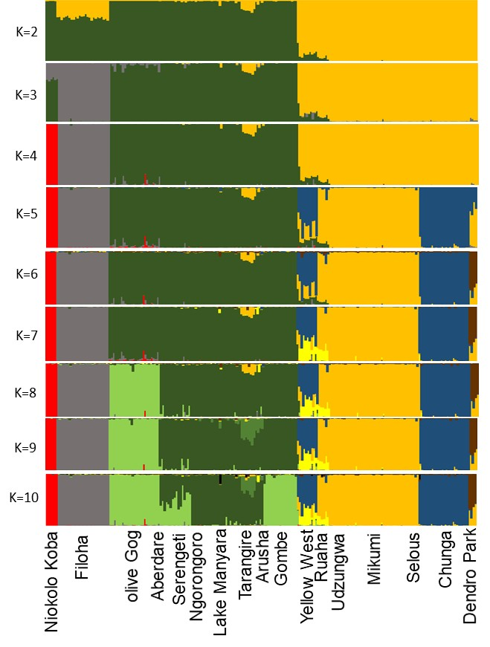
Fig. S1. STRUCTUREv.2.3.4 for 261 LINE insertions, 222 Papio baboons. 20,000 burn-in followed by 200,000 MCMC x 3 iterations for K=2-10. Mean Ln P(D) values for different Ks were: k=2 -40165, k=3 -37022, k=4 -35092, k=5 -33816, k=6 -33984, k=7 -38757, k=8 -33229, k=9 -63555, k=10 -33936. Accordingly, k=8 was determined most likely to represent the dataset. The 10th cluster did not have any individuals assigned to it.

